Vincent Preikstas

Dr. Isabelle Bichindaritz

BHI 506 Spring 2021

5/14/2021

Using Machine Learning and Digital Image Processing in Disease Diagnosis

Introduction……………………………………………………………………………………………………………………………….2

Background………………………………………………………………………………………………………………………………..2

Project Objectives……………………………………………………………………………………………………………………..3

Materials and Methods………………………………………………………………………………………………………………3

Task-relevant Data………………………………………………………………………………………………………….3

Tools………………………………………………………………………………………………………………………………4

Methods…………………………………………………………………………………………………………………………4

Results……………………………………………………………………………………………………………………………………….6

Discussion………………………………………………………………………………………………………………………………….7

Conclusion…………………………………………………………………………………………………………………………………7

References…………………………………………………………………………………………………………………………………8

Appendix……………………………………………………………………………………………………………………………………9

**Introduction:**

In healthcare accurate diagnosis is of utmost importance. Between 40,000 and 80,000 deaths occur each year in US hospitals related to misdiagnosis (Renfrow, 2019). With so much at stake any advantage or tool to increase the accuracy of diagnosis represents real value for improving outcomes for thousands of people. To this end using automated systems to both aid diagnosis and confirm diagnosis is desirable. This project attempted to use facial recognition technology to analyze people’s faces and then predict if they have Cancer. For the purpose of this study and with our limited resources no restrictions about cancer type or stage were put on training or testing images.

This study is more a proof of concept as opposed to a definitive result. Favorable results are meant to show that it may be worth investing more time into obtaining or creating collections of images to refine the facial recognition. There is also consideration for refining the methods of facial recognition to get superior results, the methods used in this study will be reviewed in the methods section later on. The hope is that later collaboration with health providers and patients could result in a much larger repository of images to do training and testing on.

In short the main question we wish to address is, is it possible to tell from facial features using facial recognition in the form of a trained model if a person has cancer. Our main hypothesis being that facial recognition technology could in fact be able to recognize a person with Cancer. We will not be rejecting any null hypothesis to accept our hypothesis with the depth of this experiment, but we will be able to provide some rough evidence to support the hypothesis.

**Background:**

There already exists a foundation that some health issues can be diagnosed through facial recognition, certain genetic disorders have already been shown to be detectable through phenotype of the face. A study done by Smail Hadj-Rabia published in 2017 showed that facial recognition proved to be a possible non-invasive technology to screen patients for extodermal dysplasia (Hadj-Rabia, 2017). There are numerous articles across various technology and medical websites that corroborate a similar sentiment. Perhaps these genetic disorders are specific cases and other disease that develop after birth and because of external factors instead of genetics will not be conducive to prediction with facial recognition, but it is worth exploring.

Cancer seemed an obvious choice as it is endemic to all people, is extremely common, can be life threatening or altering and is an ongoing battle for researchers and health care providers to treat and manage. To this end, identifying cancer as early as possible is important for having better patient outcomes. Cancer can be elusive, in a news post by The Angiogensis Foundation they reported on a study from Stanford University School of Medicine that gave evidence that malignant tumors may grow in the body for up to a decade or more without being detected. Furthermore, many tests for cancer rely on blood tests of various biomarkers that can have a lot of false positives, this can lead to misdiagnosis and wasted resources. Worse however is what is not caught when a patient who could have had an earlier and more treatable form of cancer is allowed to progress to later stages of cancer before it is identified (Angiogensis Foundation, 2012).

All of this hints that having more varied, cheap and accurate ways of diagnosing cancer early and often can yield real benefits. This is where facial recognition may be of use. We were not able to find any definitive studies looking at either different types of cancers, stages, etc. utilizing facial recognition to try to identify cancer. It may be a fool’s errand as there may not be facial expression that is common between cancer sufferers or at least things that can be recognized by existing facial recognition algorithms. Another large source of uncertainty and error could be differences between any facial expression between different forms of cancer, different demographic groups with a given cancer and different stages of cancer. Each of these could also be considered in tandem and give a different result. Controlling for all those possible factors is difficult and would require an extended study likely gathering image data for years so we will need to make do with rougher checks.

**Project Objectives:**

The main objectives of this project are as follows:

1. Find a repository of photos with AI facial recognition training friendly photos or provide enough evidence to show the merit in funding the creation of such a repository.
2. Train a facial recognition model on pictures of people with and without cancer to identify test pictures as either.

The main people who stand to benefit from this project are any practitioners who could utilize a new method in the early detection of cancer as well as the public, since such technology would be vastly easier and cheaper than most detection methods to disseminate to people. It could be as simple as a free phone application that could give people a heads up if they should seek further advice from a doctor.

**Materials and Methods**

**Task-relevant Data:**

To do facial recognition training we had to find as many portrait style photos of people with and without cancer as possible. Thirty training photos for no cancer were found and ten for cancer with eight additional photos of both cancer and no cancer being used for testing. Now these numbers are extremely low for facial recognition training, but portrait pictures of people with cancer proved hard to find. All the photos were found either through unsplash.com or google image search. It is important to note that many more photos of people with cancer were initially found but more than half of them could not be recognized by the facial recognition part of the algorithms, this may have something to do with the general whiteness of a hospital setting interfering with the algorithm parsing the face.

Below you can see two examples of faces used to do the training:

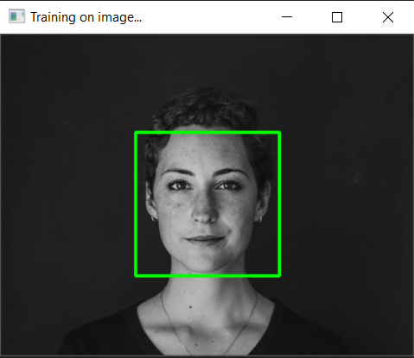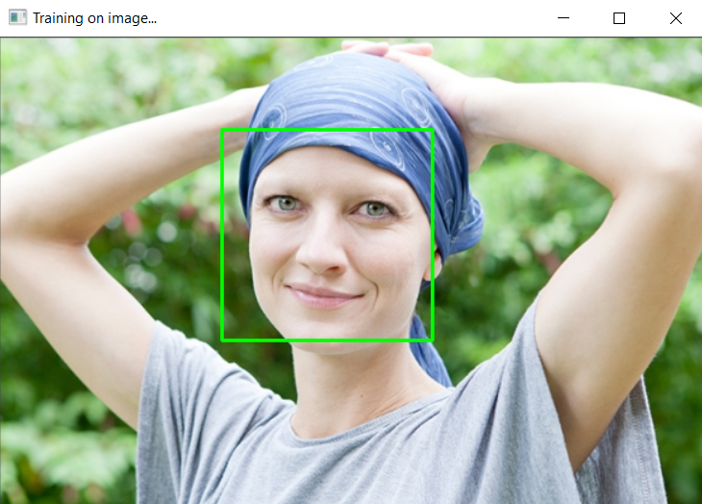

**Tools:**

In this project the Python programming language with OpenCV was used to do the facial recognition, training, and prediction. In particular a pretrained Haar cascade model was used to identify faces in the images and OpenCV’s dlib and face_recognition libraries were used to train an SVM to do predictions. OpenCV is an open-source library of computer vision functionality. All of the work was done using PyCharm by JetBrains as the IDE of choice, the Python version was 3+.

**Methods:**

The methods used in the project used the following steps:

*Note: Methods and code by Rosebrock were used as a guide for this project.

1). Find training and testing images and create a folder hierarchy related to them. Images were found using Google Image search as well as unsplash.com.

2). Use the pretrained Haar cascade classifier to computer 128-d face embeddings to extract the faces from the images.

Below you can see a snippet of the code that prepares the training data:

def prepare_training_data(training_photos_path):  
 dirs = os.listdir(training_photos_path)  
 faces = []  
 labels = []  
 face_cascade = cv2.CascadeClassifier('opencv-files/haarcascade_frontalface_alt.xml')  
  
 for dir_name in dirs:  
 if not dir_name.startswith("s"):  
 continue;  
 label = int(dir_name.replace("s", ""))  
 subject_dir_path = training_photos_path + "/" + dir_name  
 subject_images_names = os.listdir(subject_dir_path)  
 for image_name in subject_images_names:  
 if image_name.startswith("."):  
 continue;  
 image_path = subject_dir_path + "/" + image_name  
 image = cv2.imread(image_path)  
 show_image = detect_faces(face_cascade, image, 1.2)  
  
 cv2.imshow("Training on image...", show_image)  
 cv2.waitKey(0) #was 200  
 face, rect = detect_face(image)  
 if face is not None:  
 faces.append(face)  
 labels.append(label)  
 #cv2.destroyAllWindows()  
 #cv2.waitKey(1)  
 cv2.destroyAllWindows()  
 return faces, labels

And here you can see a snippet of code that detects the face in an image:

def detect_face(img):  
 gray = cv2.cvtColor(img, cv2.COLOR_BGR2GRAY)  
 face_cascade = cv2.CascadeClassifier('opencv-files/lbpcascade_frontalface.xml')  
 faces = face_cascade.detectMultiScale(gray, scaleFactor=1.2, minNeighbors=5);  
 if (len(faces) == 0):  
 print("Failed")  
 test = "test"  
 cv2.imshow("This Image Failed", img)  
 cv2.waitKey(0)  
 cv2.destroyAllWindows()  
 return None, None  
 (x, y, w, h) = faces[0]  
 return gray[y:y+w, x:x+h], faces[0]

3). Use the OpenCV face_recognizer with formatted training images with labels to train the support vector machine.

4). Use the newly trained SVM to do predictions on a set of test images.

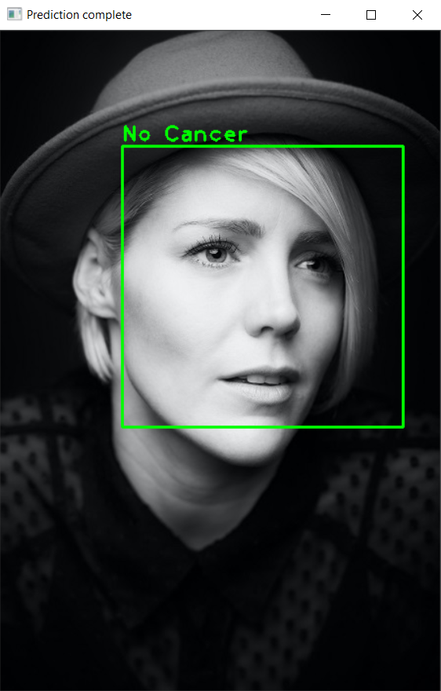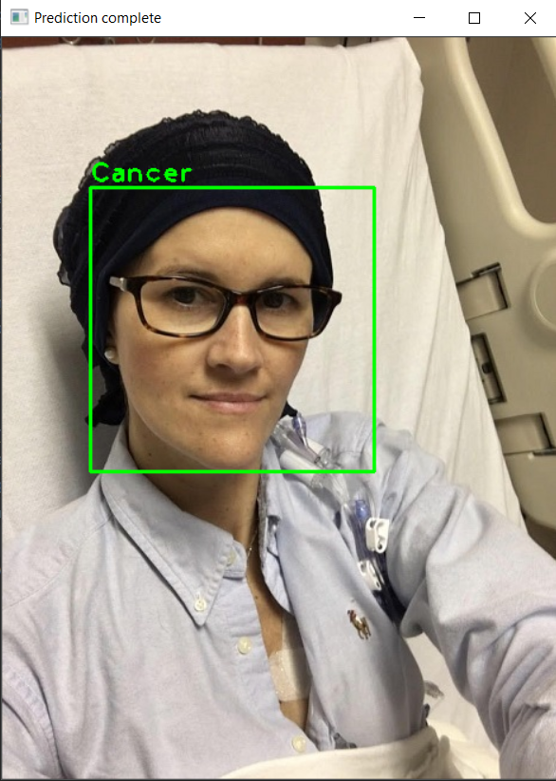Below you can see two examples of the prediction:

**Results:**

The first objective was only partially realized as a sufficient amount of training photos that were freely available online were not found. Such a collection may not exist for cancer patients particularly as it is a privacy issue. Even getting regular photos was hard and if this study was to be published issues of legality of privacy and copyright might come up.

However, given the limited number of test photos the results were compelling. Of the eight test photos seven out of eight were correctly classified as either cancer or non-cancer. This is highly surprising and has a high likelihood that it is a fluke. Running the experiment again with many more pictures and different sets of test pictures would be necessary to confirm if there is any merit to this. That given it is exciting and although it may be mostly due to dumb luck of the classifier it is showing positive results for their being a difference between those with and without cancer that the facial recognition may be picking up on. Another large source of error could be the lighting or hair. It was hard to find pictures that were portraits of non-cancer people that did not have a certain embellishment in terms of composition and lighting. Most of the cancer photos had the flat white sheen of a hospital room and almost all had no hair. This may or may not be a source of error that is a lurking variable in the positive result of this test.

**Discussion:**

As was mentioned already, the paper by Hadj-Rabia titled *Automatic recognition of the XLHDED phenotype from facial images* provides an example of facial recognition in use as a diagnostic tool and it is our belief that it is an underutilized technology. In general, it is clear the possible underutilized capability of different image processing technologies in healthcare is slowly going to give way to many new innovations with previously unthought of methods of diagnosis for patients. It is a tragedy as laid out in the Renflow article that 1 in 3 misdiagnosis result in serious injury and that misdiagnosis is as common as it is. In some situations, diagnosis is the most key part of the process as treatment is usually effective for many ailments and diseases but only if the physician knows exactly what is going on with the patient. Now that is not to say that facial recognition will revolutionize cancer diagnosis, but it could be an early warning system.

**Conclusion:**

The analysis and work done in this study has shown promising results. It may be possible that facial recognition technologies as they exist today could be used to help diagnose cancer in patients. The results were overwhelmingly positive in this study but with the sample size of the training and test sets being what they are it could be entirely by chance.

The research that really needs to happen is a long-term study in coordination with a large hospital that sees a lot of cancer patients and does a lot of treatment. What is needed is hundreds of pictures of people of varying demographics and cancer stages with portrait style shots. Also pictures of regular patients could fill the void in having many non-cancer portraits. It would be important in a more definitive study to test different groupings of pictures, such as along demographic lines or certainly cancer stages. What we really want is for a model that can predict cancer in the early stages. This kind of a project is made trickier by the privacy concerns around images of people and is less anonymous than traditional hospital data that has been scrubbed of person identifying information. Still if a hospital could be found that would agree to this it could at least answer the question if current methods of facial recognition could be used for this purpose. Even just creating the repositories of pictures could be useful as it could be that the facial recognition technology would need to be tweaked or needs a little more innovation and then could predict with a good margin of error. Having the picture repositories in the future would mean the hard part of data gathering was already done.

**References**

Hadj-Rabia, S., Schneider, H., Navarro, E., Klein, O., Kirby, N., Huttner, K., Wolf, L., Orin, M., Wohlfar, S., Bodemer, C., Grange, D. (2017). Automatic recognition of the XLHED phenotype from facial images. American Journal of Medical Genetics Part A, 173(9), 2408-2414. doi:10.1002/ajmg.a.38343

Rosebrock, A. (2018, September 24). OpenCV Face Recognition. Retrieved February 12, 2021, from <https://www.pyimagesearch.com/2018/09/24/opencv-face-recognition/>

Renfrow, J. (2019, July 11). 1 in 3 misdiagnoses results in serious injury or death: Study. Retrieved February 12, 2021, from <https://www.fiercehealthcare.com/hospitals-health-systems/jhu-1-3-misdiagnoses-results-serious-injury-or-death#:~:text=An%20estimated%2040%2C000%20to%2080%2C000,or%20permanent%20damage%20or%20death>

The Angiogenesis Foundation (2012). Cancer May Grow Undetected for a Decade or More. Retrieved April 21, 2021, from <https://angio.org/cancer-may-grow-undetected-for-a-decade-or-more/>

**Appendix**

Power Point Presentation Slides:

